**26. AWS Security Hub**

* AWS Security Hub gives you a comprehensive view of your high-priority security alerts and compliance status across AWS accounts.

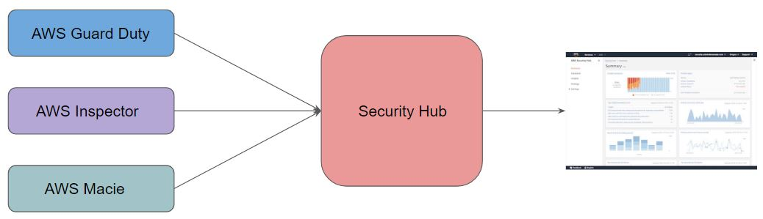

**Why we need security Hub**

* the idea of security hub can be seen in the above diagram where you have multiple services. you have guard duty, you have inspector, you have macie and you have various others.
* So generally, what happens is when you go and enable these, you will have to go to the respective console to investigate the finding. you go to the guard duty to investigate the finding. Then you go to the inspector and investigate the finding and so on. So, it becomes a very tedious.
* So, the main idea of security hub is to create a centralized place where all your security related alerts would be visible and the security engineer as well as the auditor, will only have to investigate this centralized place to look into what is missing or what alerts has been placed.

**Supported compliance standard**

* AWS Security Hub also can generate its own findings by running automated and continuous checks against the rules in a set of supported security standards.
* Following Standards are supported:
* CIS AWS Foundation
* PCI DSS

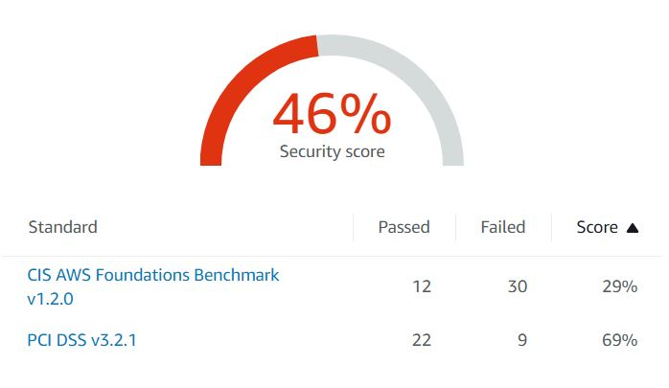

**Aws config**

--- **note** – before enabling aws security hub. we must enable aws config.

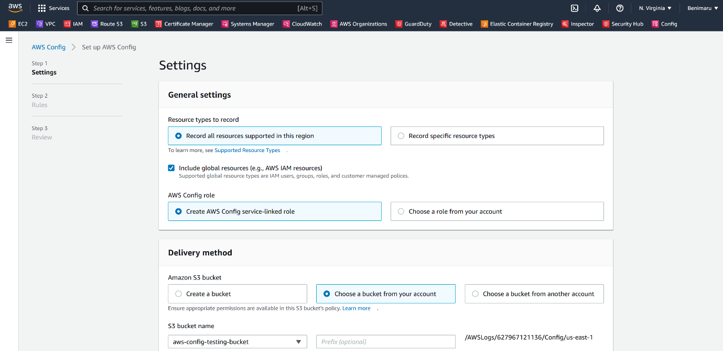



--- click on next.

--- I am skipping the rules for time being.

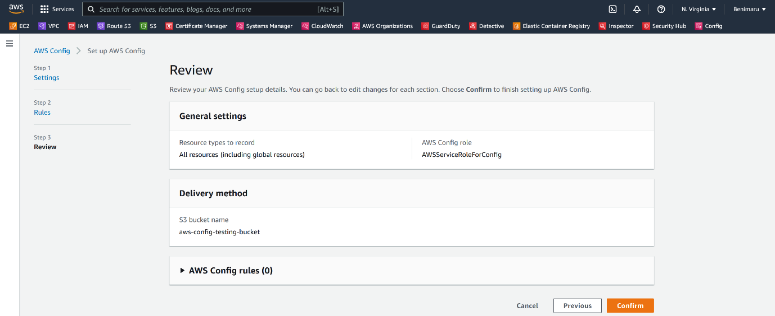

--- click on confirm.

**Security hub**

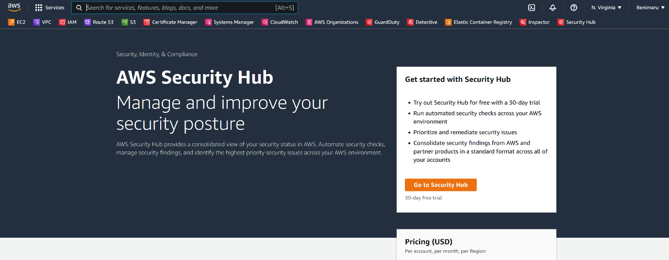

--- click on go to security hub.